15.1 Water
Name: ____________________ Class: ____________________ Due date: 11.25
1. Water for human use is treated by filtration then chlorination.
Which uses do not need water of this quality? （ ）
1 water for cooling in industry
2 water for flushing toilets in the home
3 water for drinking
A 1, 2 and 3 B 1 and， 2 only C 1 and 3 only D 2 and 3 only

2. Which processes are used in the treatment of water? （ ）
A filtration and chlorination
B filtration and reduction
C neutralisation and chlorination
D neutralisation and reduction

3. Untreated water can spread diseases such as cholera.
What can be added to drinking water to reduce the spread of such diseases?（ ）
A carbon monoxide B chlorine C nitrogen monoxide D sulfur

4. - (0620- S 2013- Paper 1 (Core)/1- Q31) - AIR AND WATER
Water has been contaminated with sea- water.
Which substances can be removed by chlorination and filtration? （ ）
A bacteria, sand and sodium chloride
B bacteria and sand only
C bacteria and sodium chloride only
D sand and sodium chloride only

5. The diagram shows a stage in the purification of dirty water.
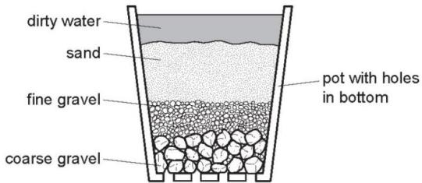
Which process does this apparatus show? （ ）
A chlorination B condensation C distillation D filtration

6. In many countries river water is used for the washing of clothes.
The same water is not considered to be safe for drinking.
Why is it not safe for drinking? （ ）
A because river water contains dissolved salts
B because river water may contain harmful bacteria
C because river water may contain small particles of sand
D because river water may contain soap from washing clothes
7. Which statements about water are correct? （ ）
1 Household water contains dissolved salts.
2 Water for household use is filtered to remove soluble impurities.
3 Water is treated with chlorine to kill bacteria.
4 Water is used in industry for cooling.
A 1,2,3 and 4 B 1,2 and 3 only C 1,3 and 4 only D 2,3 and 4 only

8. Which method of purification would produce water most suitable for drinking?（ ）
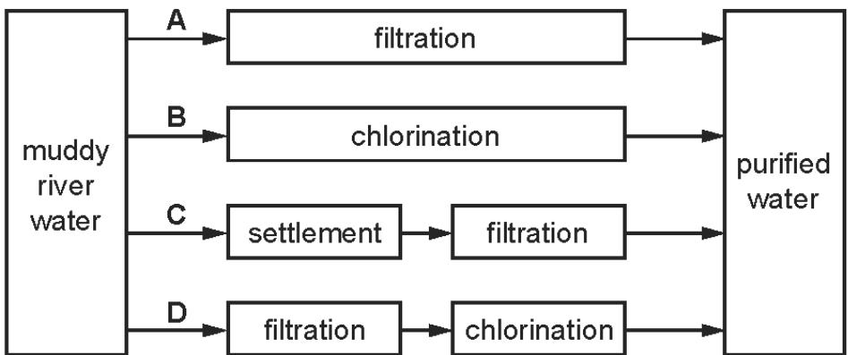
9. Which statements about water are correct? （ ）
1 Household water contains dissolved salts.
2 Water for household use is filtered to remove soluble impurities.
3 Water is treated with chlorine to kill bacteria.
4 Water is used in industry for cooling.
A 1,2,3 and 4 B 1,2 and 3 only C 1,3 and 4 only D 2,3 and 4 only

10. River water contains soluble impurities, insoluble impurities and bacteria.
River water is made safe to drink by filtration and chlorination.
Which statement is correct? （ ）
A Filtration removes bacteria and insoluble impurities, and chlorination removes soluble impurities.
B Filtration removes insoluble impurities, and chlorination kills the bacteria.
C.Filtration removes soluble and insoluble impurities, and chlorination kills the bacteria.
D.Filtration removes soluble impurities and bacteria, and chlorination removes insoluble impurities.

11. Which statement shows that a liquid is pure water? （ ）
A It boils at ${100}^{∘}C$
B It has a pH value of 7.
C It turns blue cobalt(II) chloride pink.
D It turns white copper(II) sulfate blue.

12. Which statement about pure water is not correct? （ ）
A It condenses at ${100}^{∘}C$ .
B It freezes at $0^{∘}C$ .
C It turns cobalt(II) chloride paper blue.
D It turns anhydrous copper(II) sulfate blue.
13. Which substances can be used to detect the presence of water? （ ）
1 cobalt(II) chloride
2 copper(II) sulfate
3 litmus 4 methyl orange
A 1 and 2 B 1 and 3 C 2 and 4 D 3 and 4

14. Water is needed for industry and in the home.
Rain water is collected in reservoirs.
How is it treated before entering the water supply?
.............................................................................................................................
.............................................................................................................................[2]
State two industrial uses of water.
.............................................................................................................................
.............................................................................................................................[2]
State two uses of water in the home.
.............................................................................................................................
.............................................................................................................................[1]
In many regions, drinking water is obtained by the distillation of sea-water.
Explain how distillation separates the water from sea-water.
.............................................................................................................................
.............................................................................................................................[2]

15. Describe a chemical test which shows the presence of water.
test colour change if water is present.
.............................................................................................................................
.............................................................................................................................
.............................................................................................................................[3]
How could you show that a sample of water is pure?
.............................................................................................................................[1]
Describe how water is treated before it is supplied to homes and industry.
.............................................................................................................................
.............................................................................................................................[2]

